**Ideation Phase**

**Define the Problem Statements**

|  |  |
| --- | --- |
| Date | 26 june 2025 |
| Team ID | LTVIP2025TMID37102 |
| Project Name | Smart SDLC - AI-Enhanced Software Development Lifecycle |
| Maximum Marks | 2 Marks |

**Customer Problem Statement Template:**

Create a problem statement to understand your customer's point of view. The Customer Problem Statement template helps you focus on what matters to create experiences people will love.

A well-articulated customer problem statement allows you and your team to find the ideal solution for the challenges your customers face. Throughout the process, you’ll also be able to empathize with your customers, which helps you better understand how they perceive your product or service.

Reference: <https://miro.com/templates/customer-problem-statement/>

**Example:**

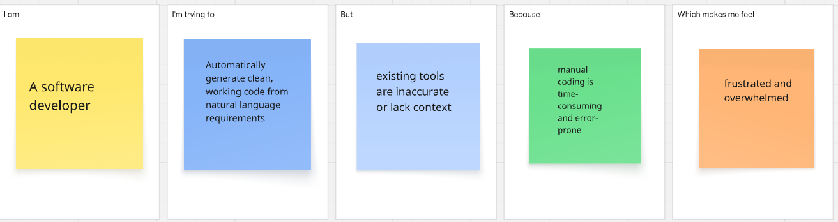

|  |  |  |  |  |  |
| --- | --- | --- | --- | --- | --- |
| **Problem Statement (PS)** | **I am (Customer)** | **I’m trying to** | **But** | **Because** | **Which makes me feel** |
| PS-1 | A software developer | Automatically generate clean, working code from natural language requirements | existing tools are inaccurate or lack context | manual coding is time-consuming and error-prone | frustrated and overwhelmed |
| PS-2 | A project manager | Speed up delivery of quality software | managing SDLC manually takes too long | my team wastes time on repetitive tasks | anxious about deadlines and client satisfaction |